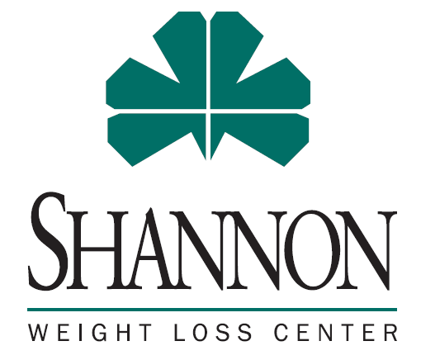
Shannon Weight Loss Center Support Group
Shannon Weight Loss Support Group is a private place to provide education, share experiences, and foster ongoing support and encouragement. Patients may join either before or after surgery.
Our Facebook support group is Shannon Weight Loss Center Support Group You can find us here:

Virtual platforms are utilized where appropriate either through Microsoft Teams or Facebook Live. Links will be shared on the Facebook support group page or emailed to you at your request. Should you have non-emergency concerns or questions, please reach out to your surgeon’s office at (325)747-2488.
Below is the support group schedule for 2026:
Date | Time | Location | Topic/Presenter
January  6th | 5:30 | Main hospital  Legacy 1 | New Year, Same You. Let’s Celebrate That!
February  24th | 5:30 | Shannon Health Club | Shannon Health Club – Janet Charlesworth
March |  | n/a | No meeting
April  7th | 5:30 | Main Hospital  Legacy 1 | Sandy Haby – pt testimonial
May |  | n/a | No meeting
June  2nd | 5:30 | Main Hospital  Legacy 2 | Coping in the summer, 4th of July Bari friendly recipes
July  14th | 5:30 | Main Hospital  Legacy 2 | Body dysmorphia
August |  | n/a | No meeting
September 22nd | n/a | Main Hospital  Legacy 1 | “Falling” into a healthy and happy you!
October  13th | 5:30 | Main Hospital  Legacy 1 | Have a Bari friendly Halloween!
November  17th | 5:30 | Main Hospital  Legacy 2 | Dr. Barbella – Staying Healthy, Less Anxious and More Present During the Holidays
December  1st | 5:30 | Main Hospital  Legacy 1 | Holiday Party! Getting through December holidays, recipe swap and social

Our Bariatric Coordinator can be reached at (325)747-5354 or at weightloss@shannonhealth.org

